Lydia Jean Herz
Home: 202.488.8268, Cell 202.494.8365
560 N Street SW #N912 * Washington DC 20024
danjeandc@verizon.net
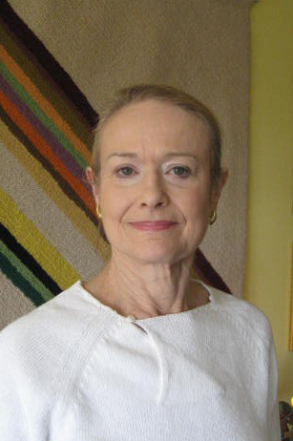

Performer Profile: Reliable – Professional – Team Player
Height: 5’7” * Weight: 140 * Age Range: 60-70
Performance Experience:
Background Actor, various media
- Passenger at Airport, “House of Cards”, Netflix, August 2013
- Senator at Congressional Hearing, Army War College training film, Will Interactive, August 2012
- Featured background in trailer for “Angelic War”, Forbidden Records & Entertainment, June 2012
- Bike race crowd member, “Better Living Through Chemistry”, May 2012
- Opera Patron, “House of Cards”, Netflix, May 2012
- Political Supporter in various scenes of HBO’s “Game Change” June 2011
- Mrs. Talley, “To Pull a Stunt”, Genuine Gypsy Productions, 2010
- Lady in Café, Department of Homeland Security Training Film, June 2010
- Lady with Yellow shirt, baseball stadium scene, “How Do You Know”, Columbia Pictures, June 2009
- Lady with Dog, “State of Play”, Universal Pictures, February 2008
Supernumerary (Background Actor), Ballet
- Elegant Lady, 5 performances of “Romeo and Juliet” American Ballet Theater, Kennedy Center, January 2010
- Manon’s Mother, 5 performances of “Manon”, Royal Ballet, Kennedy Center June 2009
Commercial (Background)
- Background for Big Bus Sightseeing Tours’ website video, Washington DC, July 2013
Training
- John Strawbridge: Intro to Film Industry, Background Acting
Special Skills and assets:
- Certified SCUBA Diver
- Skilled Equestrienne (eastern, western and endurance horses/saddles)
- Qualified in .22, .38 handguns

