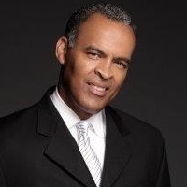

Randy Clarke
Email: rcjur@hotmail.com

Actor / Commercial Print Model

SAG Eligible - Non Union
Height - 6 2”

Weight - 185
Age Range - 50 - 60

Credits

Television:

The Wire - Blown Deadline Production - Extra (3 Episodes)
The District - CBS Production - Extra
Forensic Files - Weinberger Media - Detective (2 Episodes)

La Fortuna - MOD Productions/AMC - Police Officer

We Own This City – HBO Productions - US Marshall

Film:
Random Hearts - Random Hearts Production - Panel Member
Carrie II - Universal Production - Teacher
The Agency - The Agency Production - Extra
7 Days “Pilot”- Police Officer

Commercials:
Horseshoe Casino - Caesars

Industrials/Print:
Riggs Bank

Page Ave - Internet Web Ad

Emery Mill

USSS Law Enforcement Training Video

3D Scanning Technology - Sparrow Seven Production

Travel Campaign Ad – Visit Alexandria VA

Training: Auditioning, Commercials, Acting In-Front Camera - Chuck Paris

Special Skills: Sports, Biking, Dancing. Enjoy family, kids, and dogs. 3 Ep

